1. Now, we know that Docker Server is a set of processes.
   1. Docker Daemon.
   2. ContainerD
   3. Runc
   4. DockerInit
2. Now the question is where those processes are running?
3. They are running on **Docker Host**.
4. What is **Docker Host**?
   1. Jatin: Docker host is the machine on which Docker Engine runs.  
      Docker Engine always runs on Linux Machine.  
      So, there are two cases:  
      **Case 01**: You’re using Linux machine, then you install Docker Engine directly on the Linux Machine.  
      **Case 02**: You’re using Windows or Mac, then you first install Docker Desktop which install tiny Linux machine on your machine and on that Linux machine, Docker Engine is installed.   
      And we know that where Docker Engine is installed is called Docker Host.
5. Let’s go back to the diagram.
6. If we’re installing Docker engine directly on Linux machine, then the **Linux machine** is Docker Host and all the processes from the Docker engine are running on this Linux machine directly.
7. If it’s MAC OS or windows, then we have to install a tiny Linux VM on top of these machines and this tiny Linux machine would be Docker Host.
   1. And inside this tiny Linux VM, all the Docker Server’s processes would be running.
   2. And all the containers would be created and running inside this tiny Linux VM.
8. 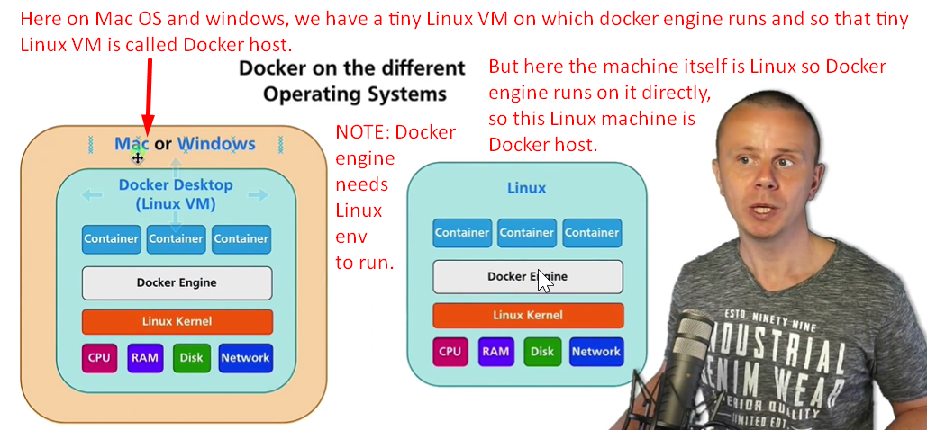
9. From Time 1:25, the lecture is a little about Linux so not clear come back later.